**Monash / La Trobe University Lecture**

**[Individual Task 1: Naïve Bayes]**

 

**Gachon University**

**Software Dept.**

**Seungsoo Lee**

**[Dataset]**

**-Training Set**

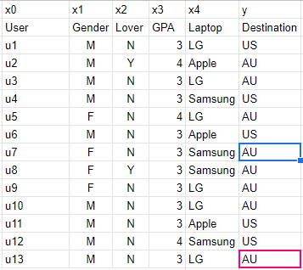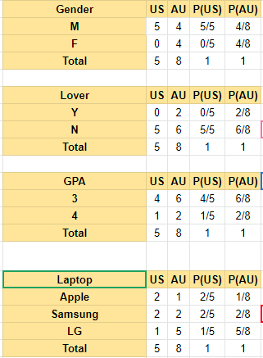

**Q1.**

|  |
| --- |
| P(US | F, Y, 4,Apple)=0  P(AU | F, Y, 4,Apple)=more than P(US | F, Y, 4,Apple)  P(US | F, Y, 4,Apple)=0 < P(AU | F, Y, 4,Apple)  Result = P(AU) |

A

**Q2. Estimate which nation will be choosed: M,N,3,Apple**

|  |
| --- |
| US:  P(M | US) * P(N | US) * P(3 | US) * P(Apple | US) * P(US) = ***5/5*5/5*4/5*2/5*5/13 = 8/65***  AU:  P(M | AU) * P(N | AU) * P(3 | AU) * P(Apple | AU) * P(AU) = ***4/8*6/8*6/8*1/8*8/13=9/416*** |

Result: US

**Q3. Estimate which nation will be choosed: M,Y,4,LG**

|  |
| --- |
| US:  P(M | US) * P(Y | US) * P(4 | US) * P(LG | US) * P(US) = ***5/5 * 0/5 * 1/5 * 1/5 * 5/13 = 0***  AU:  P(M | AU) * P(Y | AU) * P(4 | AU) * P(LG | AU) * P(AU) = ***4/8 * 2/8 * 2/8 * 5/8 * 8/13 = 5/416*** |

Result: AU

**Q4. Estimate which nation will be choosed: M,Y,3,Samsung**

|  |
| --- |
| US:  P(M | US) * P(Y | US) * P(3 | US) * P(Samsung | US) * P(US) = ***5/5*0/5*4/5*2/5 *5/13= 0***  AU:  P(M | AU) * P(Y | AU) * P(3 | AU) * P(Samsung | AU) * P(AU) = ***4/8*2/8*6/8*2/8*8/13=3/208*** |

Result: AU

